A

Technical Report

on

**AUTHORISED ENTRY INTO ARMY ZONE**

*Submitted to CMR Institute of Technology in the partial fulfillment of the requirement of*

**Social Innovation Lab**

Of

**II B.Tech I- Semester**

in

**ECE DEPARTMENT**

Submitted by

**B.PRUTHVI RAJ. (20R01A04D0)**

**M.SANKEERTHAN REDDY. (20R01A04F4)**

**MOHAMMAD SHADAB (20R01A04F9) Y.JASHWANTH REDDY. (20R01A04H9)**

**K.PREM KUMAR. (20R05A0417)**

***Under the esteemed guidance of***

*Ms.Y.Sushma*

*Assistant Professor*



**CMR INSTITUTE OF TECHNOLOGY**

**(UGC-AUTONOMOUS)**

(Approved by AICTE, Permanently Affiliated to JNTU Hyderabad, Accredited by NBA, Accredited by NAAC with A Grade)

Kandlakoya (V), Medchal Road, Hyderabad  501 401

2021-2022

***Department of ECE***

**Certificate**

This is to certify that the technical report entitled“AUTHORISED ENTRY INTO ARMY ZONE” is the bonafidework done and submitted by

B.PRUTHVI RAJ. (20R01A04D0)

MOHAMMAD SHADAB. (20R01A04F9)

M.SANKEERTHAN REDDY. (20R01A04F4)

Y.JASHWANTH REDDY. (20R01A04H9)

K.PREM KUMAR. (20R05A0417)

towards the partial fulfillment of the requirement of Social Innovation (SIL) Laboratory of **II B. Tech I-Semester** in **ECE** is a record of bonafide work carried out by them during the period **sep 2021 to jan 2022.**

**Guide Co- Ordinator Head of Department**

***Ms.Y.Sushma Mr.Gopala Krishna Dr.K.Niranjan Reddy***

***Assistant professor. Assistant professor. ECE Department***

***Civil Department ECE Department***

**INDEX**

**Topics Page No**

**CHAPTER-I INTRODUCTION 1**

**CHAPTER -II Empathize 4**

**CHAPTER -III Define**  5

**CHAPTER -IV Ideate 6**

**CHAPTER -V Prototype 6**

**CHAPTER -VI Test 16 reference 17**

1. **INTRODUCTION**

* **WHAT IS SOCIAL INNOVATION?**

The term ‘social innovation ’once rarely heard is ,now often used to describe a whole variety of things that fall into general categories of being both new and good.It’s understandable that the phrase has become popular-we get excited and hopeful when it seems possible for real change to happen in the world.

Social innovation refers to the Design and implementation of new solutions that imply conceptual ,process ,product or organisational change which ultimately aim to improve the welfare and wellbeing of individual communities

Social innovation is not a new concept and should not be considered similar to other definitions, such as social entrepreneurship, creativity or invention, improvement or change. 'As with innovation in technology or business, social innovation is distinct from ‘improvement’ or ‘change’ and from ‘creativity’ and ‘invention’. These last two are both crucial to innovation but overlook the important stages of implementation and diffusion which make new ideas useful.

* **What is design thinking process?**

Design Thinking is a design methodology that provides a solution-based approach to solving problems. It’s extremely useful in tackling complex problems that are ill-defined or unknown, by understanding the human needs involved, by re-framing the problem in human-centric ways, by creating many ideas in brainstorming sessions, and by adopting a hands-on approach in prototyping and testing. Understanding these five stages of Design Thinking will empower anyone to apply the Design Thinking methods in order to solve complex problems that occur around us — in our companies, in our countries, and even on the scale of our planet.

Design thinking originally came about as a way of teaching engineers how to approach problems creatively, like designers do. One of the first people to write about design thinking was John E. Arnold, professor of mechanical engineering at Stanford University.

**1**

**The five stages of design thinking:**

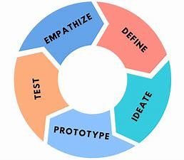

1. Empathize-The Design Thinking process starts with empathy. In order to create desirable products and services, you need to understand who your users are and what they need.
2. Define- In the second stage of the Design Thinking process, you’ll define the user problem that you want to solve.
3. Ideate.-The third stage in the Design Thinking process consists of ideation or generating ideas. ...
4. Prototype- In the fourth stage of the Design Thinking process, you’ll turn your ideas from stage three into prototypes.
5. Test -The fifth step in the Design Thinking process is dedicated to testing: putting your prototypes in front of real users and seeing how they get on.

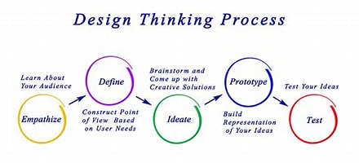

**2**

1. **Empathize**

The first stage of the Design Thinking process is to gain an empathic understanding of the problem you are trying to solve. This involves consulting experts to find out more about the area of concern through observing, engaging and empathizing with people to understand their experiences and motivations, as well as immersing yourself in the physical environment so you can gain a deeper personal understanding of the issues

involved. Empathy is crucial to a human-centered design process such as Design Thinking, and empathy allows design thinkers to set aside their own assumptions about the world in order to gain insight into users and their needs.

We have collected information from various sources like conducting surveys among the people about their problems as they are facing right now and interviewing people, reading novels from various books ,collecting information from the internet.

As our team has conducted a survey among the people at the current problems they are facing we have got many problems to be listed .In those information we have found many valid problems as they are facing in the day to day life and the collected information have been segregated accordingly.

We have shortlisted few problems which are being affected by the most people in the society .

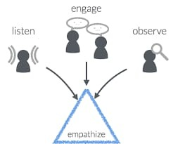

So , have chosen one of the problem that is the army security the problem faced by many army people from the terorist attacks and bomb blasts from the terrorists it causes death.

**3.Define**

In this define stage, we have defined the problem statement accordingly to our problem. According to the scenario as we have collected information in the empathy stage we have defined the problem statement as “AUTHORISED ENTRY INTO ARMY ZONE”

**3.1. Problem Statement**

Our country strongly believe the slogon i.e jai javan

jai kisaan

When a country is protected by soldier that is the strongest nation so we should support the soldier so we need strong security system to protect them by saving from the attacts like ,The 2019 Pulwama attack occurred on 14 February 2019, when a convoy of vehicles carrying Indian security personnel on the Jammu–Srinagar National Highway was attacked by a vehicle-borne suicide bomber at Lethapora in the Pulwama district of the erstwhile state of Jammu and Kashmir.

There are many methods to control the attacks with security systems but it is very costly .

**3.2 Objective :-**

* The main motto of our project is that to save the Army people from the terrorists attacts bomb blasts and etc.
* To combine advanced detection security system and alerting methods for the army people.

**3.3 ADVANTAGES AND DISADVANTAGES OF EXISTING SOLUTIONS**

**1. AUTHORISED ENTRY INTO ARMY ZONE :-**

**ADVANTAGES:-**

* The device saves the life's of the army people.
* **No need of many army or other for security outside of the army zone .**
* It cost less and offerdable.

**DISADVANTAGES:-**

* Need man power for swithing purpose.
* Some time it fails due to some power issues .
* Should check the device every time.

**4.Ideate**

In this design thinking process we have ideate as the next stage and we have come up with a solution according to the above problem statement as we have mentioned.

Our model is made with Arduino board connected with ultra sonic sensor and servomotor with a buzzer and a flat surface is the road in working model we used a pad it works when an unknown vehicle comes from the outside of the army zone so ultrasonic sensor identify the vehicle and the buzzer start ringing and the road start lifting by the servo motor so that vehicle will get damage so it can't be alloweded into the army zone if the identified vehicle comes to the army zone it start ringing but the man where to switch off it .

**5.Prototype**

The next step is making a prototype , that is for making a prototype we require components like

**COMPONENTS REQUIREMENTS :-**

1) Servo motor.

2) Buzzer.

3) Usb adaptor .

4) Switch .

5) Arduino UNO.

6) Ultrasonic sensor.

7) 9v Battery/cabel .

8) Pad.

9) Wires.

**(i) Buzzer:-**

An audio signaling device

May be mechanical, electromechanical, or piezoelectric

Typical uses of buzzers and beepers include alarm devices, timers and confirmation of user input such as a mouse click or keystroke

Used as output device in alarm systems

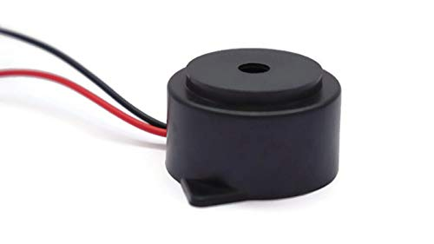

**(ii) Battery:-**

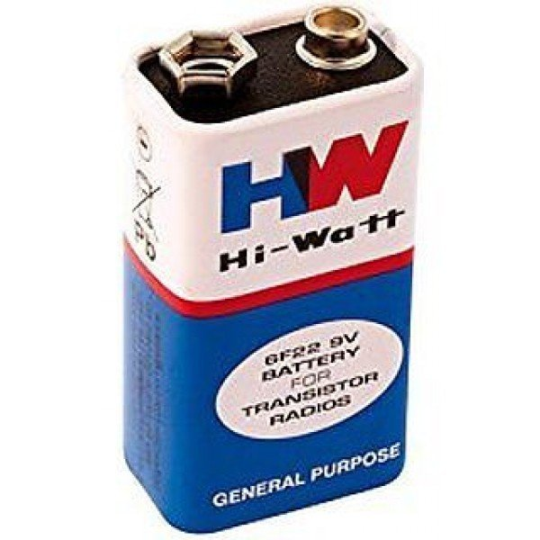

**The nine-volt battery, or 9-volt battery, is a common size of battery that was introduced for early transistor radios. It has a rectangular prism shape with rounded edges and a polarized snap connector at the top.**

(iii)  **USB CABLE :-**

* The term USB stands for **"Universal Serial Bus"**.  USB cable assemblies are some of the most popular cable types available, **used mostly to connect computers to peripheral devices** such as cameras, camcorders, printers, scanners, and more.USB cables carry power as well as signals.  This allows for "USB powered" gadgets as well as recharging batteries in cameras and other USB peripherals
* 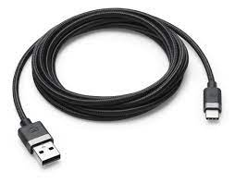USB cables are designed with several distinct connector types, making it easy to identify which plug goes into the computer and which plug goes into the peripheral device

**(iv) ON AND OFF SWITCH:-**

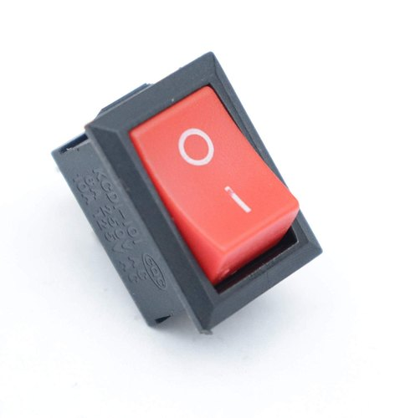The well-known on/off power symbol was the result of the logical evolution in user interface design. Originally, most early power controls consisted of switches that were toggled between two states demarcated by the words On and Off. As technology became more ubiquitous, these English words were replaced with the universal symbols line "|" and circle "o" to bypass language barriers. This standard is still used on toggle power switches.

The symbol for the standby button was created by superimposing the symbols "|" and "o"; however, it is commonly interpreted as the numerals "0" and "1". Yet the

(V) ULTRASONIC SENSOR:-

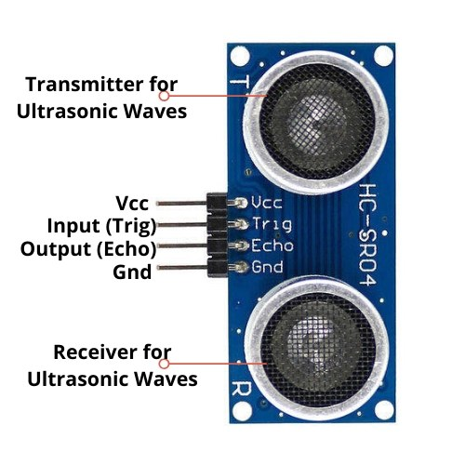

* Moreover An ultrasonic sensor can generate high frequency sound waves and can also evaluate the echo which is received back by the sensor.
* Measuring the timer interval between sending the signal and receiving the echo will determine the distance of an object, in addition the passive ultrasonic sensors are mainly microphones which will detect the ultrasonic noise that is present, it will then convert it to an electrical signal and lastly report it to the computer.

**(VI) SERVO MOTOR:**

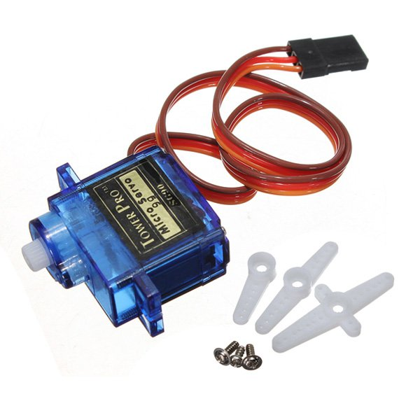

**A servo is a small device which has an output shaft which positions on coded signal. It is a rotary or linear actuator that allows for precise control of angular or linear position, velocity and acceleration.**

**The servo motor is which respond to signal abruptly and accelerate the load quickly are called servo motor.**

**Servos have a limited servo range; most servos have a range of 180 degrees, some have a range of 90, 120, 150, or 210.**

**Ultrasonic sensors will convert ultrasound waves to electrical signals, the ones which transmit and receive are called ultrasound transceivers, in addition the devices work on radar**

**(VII) Circuit diagram:-**

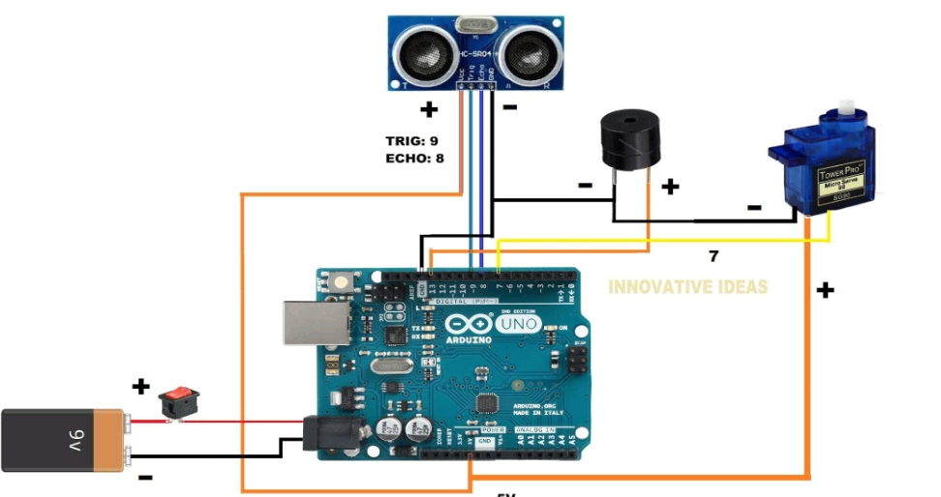

**(VIII) Arduino Uno:-**

**Product Description:** Arduino is an open source computer hardware and software company, project, and user community that designs and manufactures single-board microcontrollers and microcontroller kits for building digital devices and interactive objects that can sense and control objects in the physical world. The boards are equipped with sets of digital and analog input/output (I/O) pins that may be interfaced to various expansion boards (shields) and other circuits. The boards feature serial communications interfaces, including Universal Serial Bus (USB) on some models.

The microcontrollers are typically programmed using a dialect of features from the programming languages C and C++.

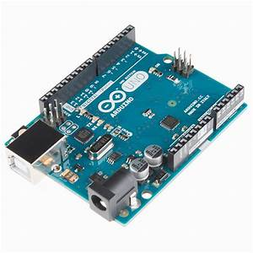

**SOURCE CODE**

Arduino code

// ---------------------------------------------------------------- //

// Arduino Ultrasoninc Sensor HC-SR04

// Re-writed by Innovative ideas

// Using Arduino IDE 1.8.7

// Using HC-SR04 Module

// Tested on 8 September 2021

// ---------------------------------------------------------------- //

#include <Servo.h>

Servo myservo;

#define echoPin 8 // attach pin D8 Arduino to pin Echo of HC-SR04

#define trigPin 9 //attach pin D9 Arduino to pin Trig of HC-SR04

#define buzzer 13

// defines variables

long duration; // variable for the duration of sound wave travel

int distance; // variable for the distance measurement

void setup() {

pinMode(trigPin, OUTPUT); // Sets the trigPin as an OUTPUT

pinMode(buzzer, OUTPUT);

pinMode(echoPin, INPUT); // Sets the echoPin as an INPUT

Serial.begin(9600); // // Serial Communication is starting with 9600 of baudrate speed

Serial.println("Ultrasonic Sensor HC-SR04 Test"); // print some text in Serial Monitor

Serial.println("with Arduino UNO R3");

Serial.begin(9600);

myservo.attach(7);

myservo.write(0);

}

void loop() {

// Clears the trigPin condition

digitalWrite(trigPin, LOW);

delayMicroseconds(2);

// Sets the trigPin HIGH (ACTIVE) for 10 microseconds

digitalWrite(trigPin, HIGH);

delayMicroseconds(10);

digitalWrite(trigPin, LOW);

// Reads the echoPin, returns the sound wave travel time in microseconds

duration = pulseIn(echoPin, HIGH);

// Calculating the distance

distance = duration * 0.034 / 2; // Speed of sound wave divided by 2 (go and back)

// Displays the distance on the Serial Monitor

Serial.print("Distance: ");

Serial.print(distance);

Serial.println(" cm");

if(distance < 20)

{

myservo.write(150);

digitalWrite(buzzer,HIGH);

delay(2000);

digitalWrite(buzzer,LOW);

delay(2000);

}

}

**WORKING MODEL**

. working of authorised entry into army zone by vehicle

. when a authorised vehicle enter through the entry gate the guard at the gate gives access to go through the gate

.But when the unauthorised vehicle comes near(<20cm) .

.Sensor sends the signal to the Arduino which instructs Servo motor to lift the obstacle on the road and triggers the alarm and vehicle stops

.It gives time to alert other security systems

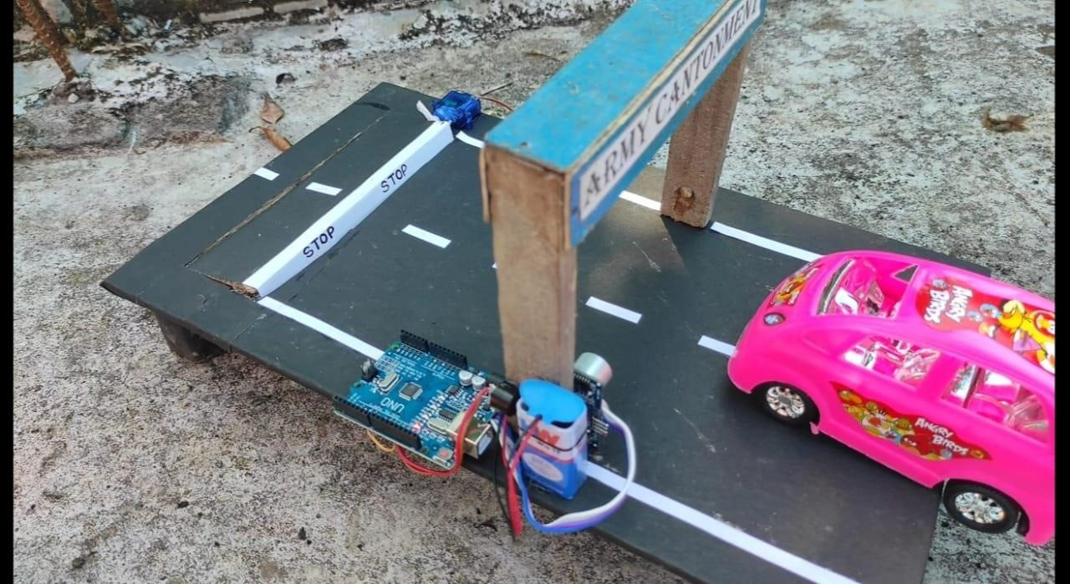

**6.test**

We have tested the code in the Arduino UNO app several times but we got a lot of errors in our code after compiling. then we edited the code and we compiled it again in Arduino UNO app but again and again we got a lot of errors .then we can able to find the major error in the code and edited it after that we compiled the code again then we got no errors and we uploaded the code to the Arduino and while uploading the code we make sure that we are connected to the port and we make sure that we selected the type of Arduino and port and then we uploaded the Arduino UNO code using the rightarrow. Then we connected all the components such as servo motor, ultrasonic sensor, buzzer battery to the Arduino UNO with the help of soldering after that we switch on the prototype type but the Arduino was not got power on so we decided to remove one by one components from the Arduino firstly we removed ultrasonic sensor by removing it the Arduino got on then we find that the problem is with ultrasonic sensor it was not working well then we replaced it with new ultrasonic sensor after that we tested our prototype again it worked successfully the ultrasonic sensor sense the vehicle and the ultrasonic sensor send the instructions to the Arduino then the Arduino send the instructions to the servo motor with the instructions which are sent by the Arduino the servo motor lift the road and block the vehicle.after that we find the major problem that the components which are connected to the Arduino are dispatching from the Arduino frequently then we decided to connect all the components with the help of jumper wires then we connected all the components to the Arduino with jumper wires after that we turn on our prototype it worked successfully.

**REFERENCES:-**

*1) https://innovativeideasyoutube.blogspot.com/2021/10/army-safety-projectcode.html*

*2) https://youtu.be/cAuqpjCkdIk*

*3) https://innovativeideasyoutube.blogspot.com/2021/10/army-safety-project-circuit-diagram.html*

*4) https://youtu.be/tQH2ugPcrL0*

*5) https://quartzcomponents.com/*

*6) https://innovativeideasyoutube.blogspot.com/2021/10/army-safety-project-circuit-diagram.html*